Balance the Dueling National Park Service Mandates
Important Terms

Dueling: _____________________________________ Mandate ____________________________________
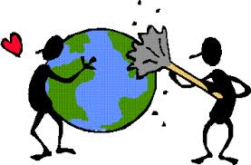
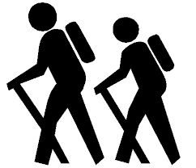
Preservation: ________________________________ Use: _______________________________________

NPS Mandate: Provide opportunities for citizens to USE and ENGAGE with the public lands and waters.
- Why is preservation of the public lands and waters important?

- What steps can rangers and the NPS take to preserve public lands and waters?

NPS Mandate: PRESERVE the Public Lands, and Waters
- Why is preservation of the public lands and waters important?

- What steps can rangers and the NPS take to preserve public lands and waters?
Think About It: Why do these two mandates duel? When would these mandates conflict?

